**Synopsis**

The learning objectives of this seminar are closely related to the lecture this week, please go through the lecture slides if you haven’t done yet.

1. Operator Overloading

2. Arrays and Objects

***Answers are provided at the end of this file.***

# **Operator Overloading**

1. Consider the following **Distance** class:



To the Distance class above, add an overloaded - operator that subtracts two distances. It should allow statements like ***dist3=dist1-dist2***. Assume that the operator will never be used to subtract a larger number from a smaller one (that is, negative distances are not allowed).

1. Write a program that substitutes an overloaded += operator for the overloaded + operator in the program below. This operator should allow statements like

***s1 += s2;***

where s2 is added (concatenated) to s1 and the result is left in s1. The operator should also permit the results of the operation to be used in other calculations, as in s3 = s1 += s2;

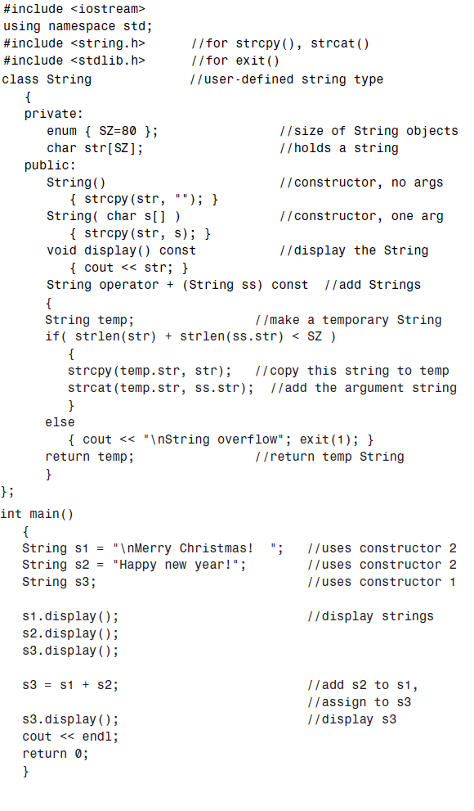

# **Array and Objects**

1. Write a program that calculates the average of up to 100 English distances (see the **Distance** class in Exercise 1 above) input by the user. Create an array of objects of the Distance class. To calculate the average, you can use the ***add_dist()*** function shown below. You’ll also need a member function that divides a Distance value by an integer. Here’s one possibility:

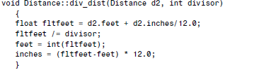

add_dist() function:

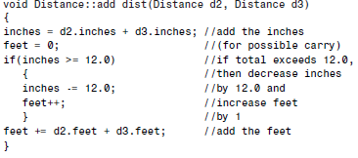

# **Answers:**

1.





2.





3.

